Step 1: FastAPI WebSocket Server
# a2a_server.py
from fastapi import FastAPI, WebSocket
from pydantic import BaseModel
import json
app = FastAPI()
class Observation(BaseModel):
agent_id: str
position: dict
velocity: dict
emotion: str
class Action(BaseModel):
agent_id: str
command: str
message: str
@app.websocket("/ws")
async def agent_endpoint(websocket: WebSocket):
await websocket.accept()
print("[Server] Agent connected.")
try:
while True:
data = await websocket.receive_text()
obs = Observation.parse_raw(data)
print(f"[Observation] {obs.agent_id}: {obs.position}")
# Simple logic: respond to emotion
if obs.emotion == "afraid":
command = "retreat"
else:
command = "explore"
action = Action(
agent_id=obs.agent_id,
command=command,
message=f"{obs.agent_id} should {command} now."
)
await websocket.send_text(action.model_dump_json())
except Exception as e:
print("Disconnected or error:", e)
Step 2: Agent (Client) Code
# agent_a.py
import asyncio
import websockets
import json
import random
async def agent_loop():
uri = "ws://localhost:8000/ws"
async with websockets.connect(uri) as ws:
for i in range(3):
obs = {
"agent_id": "AgentA",
"position": {"x": i, "y": i+1},
"velocity": {"x": 0.5, "y": 0.1},
"emotion": random.choice(["neutral", "afraid"])
}
await ws.send(json.dumps(obs))
print("[Sent]", obs)
response = await ws.recv()
print("[Received Action]", json.loads(response))
await asyncio.sleep(1)
asyncio.run(agent_loop())
Agent-to-Agent Interaction Pattern
In a real A2A system:
- Multiple agents connect to a shared communication server or hub
- Each agent can send observations and receive responses
- Agents can also broadcast, subscribe, or direct message other agents
You can build on this:
- Add agent IDs for routing
- Create a broker for indirect communication
- Implement reward feedback loops
Real-World Use Cases
Press enter or click to view image in full size
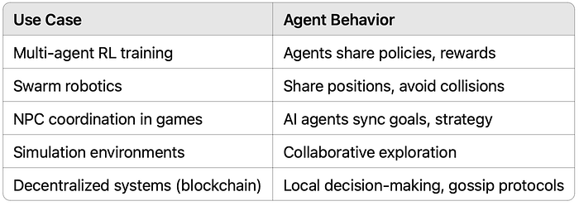
Next Steps and Best Practices
- Use UUID to track sessions per agent
- Add a message broker for scalable routing (e.g., Redis Pub/Sub)
- Support agent-to-agent direct messaging
- Integrate reinforcement learning feedback loops
- Serialize in MessagePack or protobuf for performance
🎉 Final Thoughts
Agent-to-Agent communication is a core component of any intelligent, decentralized, or cooperative system. Using Python with tools like FastAPI and WebSockets, you can quickly prototype interactive agents that learn, collaborate, or compete in real-time.

